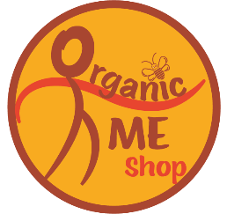OrganicME Shop

Honey Organic £10.00

Ceramic Honey Pot £20.00

Coconut shell candle £10.00

Reusable cotton wipes £10.00

Reusable Honeycomb Food wrap £3.00

Tee Tree Handmade Soap £10.00

Tote Bag £15.00

Coconut Bowls and Spoons gift set £20.00

Queen Bee and Keeper Mugs £15.00

Vintage jars £5.00

Wooden Honey Drizzler £8.00